SWANTON NOVERS COMMUNITY LAND TRUST
COMMUNITY ORCHARD
VOLUNTEER, HEALTH & SAFETY, MANAGEMENT HANDBOOK
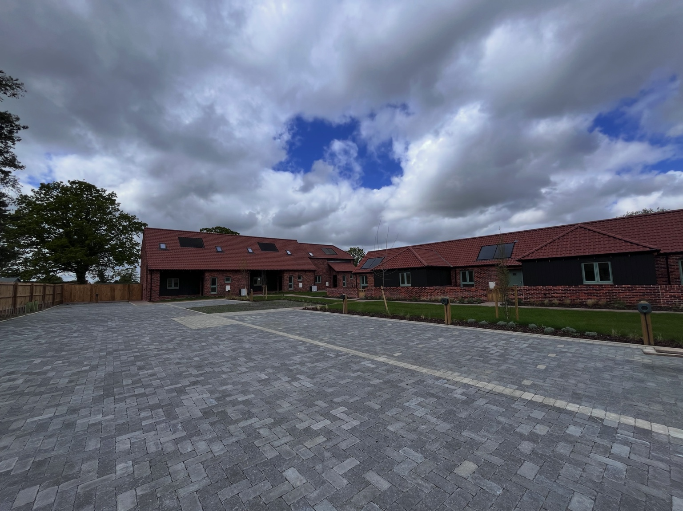
St Edmunds Court, Swanton Novers
Version 1.0
Responsible Officer: Dr Ian Watson
Secretary, Swanton Novers Community Land Trust
Contact: +44 7939 228163

Document Control
Location: St Edmunds Court, Swanton Novers
Responsible Officer: Dr Ian Watson, Secretary, Swanton Novers Community Land Trust
Review annually.

Purpose and Vision
The Swanton Novers Community Orchard has been established as a shared community asset for the benefit of present and future residents. It promotes biodiversity, environmental stewardship, community participation and enjoyment of locally grown fruit within an attractive and accessible public space.

Site Description
The orchard forms part of the St Edmunds Court development and includes fruit trees, open grassland, a seating area and a public footpath. Tree species include apple, cherry, plum and damson.

Insurance Arrangements
The CLT maintains Public Liability Insurance and Employers’ Liability Insurance of £5,000,000 on each policy.

Volunteer Responsibilities
Volunteers must work safely, follow guidance, report hazards and accidents, and act responsibly towards visitors and fellow volunteers.

Volunteer Induction
New volunteers should receive a briefing along with a copy of this handbook covering the site layout, emergency arrangements, tool use and current activities.

Health and Safety Policy
The CLT is committed to providing a safe environment for volunteers, residents and visitors. Risks will be managed proportionately to the scale of the orchard.

Personal Protective Equipment
Suitable footwear should always be worn. Gloves should be used where appropriate. Additional PPE may be required for mowing, scything or pruning.

Tool Safety
Only use tools you are competent to use. Inspect tools before use and remove damaged tools from service.

Seasonal Activities
Watering, mowing, scything, pruning, mulching, raking, fruit collection, litter picking and general maintenance, including an annual inspection of the seating area.

Public Footpath Management
Volunteers must remain aware of pedestrians and suspend activities if necessary to ensure safety.

Seating Area and Visitor Safety
The seating area should be inspected periodically and kept free from hazards.

Lone Working
Organised sessions should normally involve at least two volunteers. Where lone working occurs, such as watering, another person should be informed.

Environmental Stewardship
Management should encourage biodiversity and protect wildlife habitats.

Safeguarding
The orchard is a public space. Volunteers should act appropriately towards children and vulnerable adults and report concerns.

First Aid
The CLT will provide a basic first aid box to be available when there is any on-site volunteer group maintenance work.

Emergency Procedures
In an emergency call 999 and provide the location as St Edmunds Court Community Orchard, The Street, Swanton Novers, NR24 2FA.

Volunteer Code of Conduct
Treat others respectfully, support the aims of the CLT, care for equipment and promote a welcoming environment.

Detailed Risk Assessment
Hazard | Who at Risk | Likelihood | Severity | Score | Controls | Residual
Slips/trips | Volunteers/Public | 2 | 2 | 4 | Good housekeeping; suitable footwear | Low
Hand tools | Volunteers | 2 | 3 | 6 | Briefing; gloves; safe distances | Low
Pruning | Volunteers | 2 | 3 | 6 | Correct tools; avoid overreach | Low
Mowing/scything | Volunteers/Public | 3 | 3 | 9 | Competent operators; exclusion zone | Medium
Weather | Volunteers | 2 | 3 | 6 | Hydration; sun protection | Low
Allergens/stings | All | 2 | 3 | 6 | Awareness; medication | Low
Public footpath | All | 2 | 2 | 4 | Keep path clear | Low
Manual handling | Volunteers | 2 | 2 | 4 | Safe lifting | Low

Incident Report Form – Details Required
Date:
Person Reporting:
Details:
Actions Taken:
Volunteer Attendance Register Details (Required for any maintenance work – other than watering which can be carried out by one volunteer)
Date of gathering:
Volunteer Names | Arrival | Departure

Trustee Approval
Approved by the Trustees of Swanton Novers Community Land Trust.
Date: 1 July 2026
CLT Secretary: Dr Ian Watson

Appendix A – Orchard Site Plan
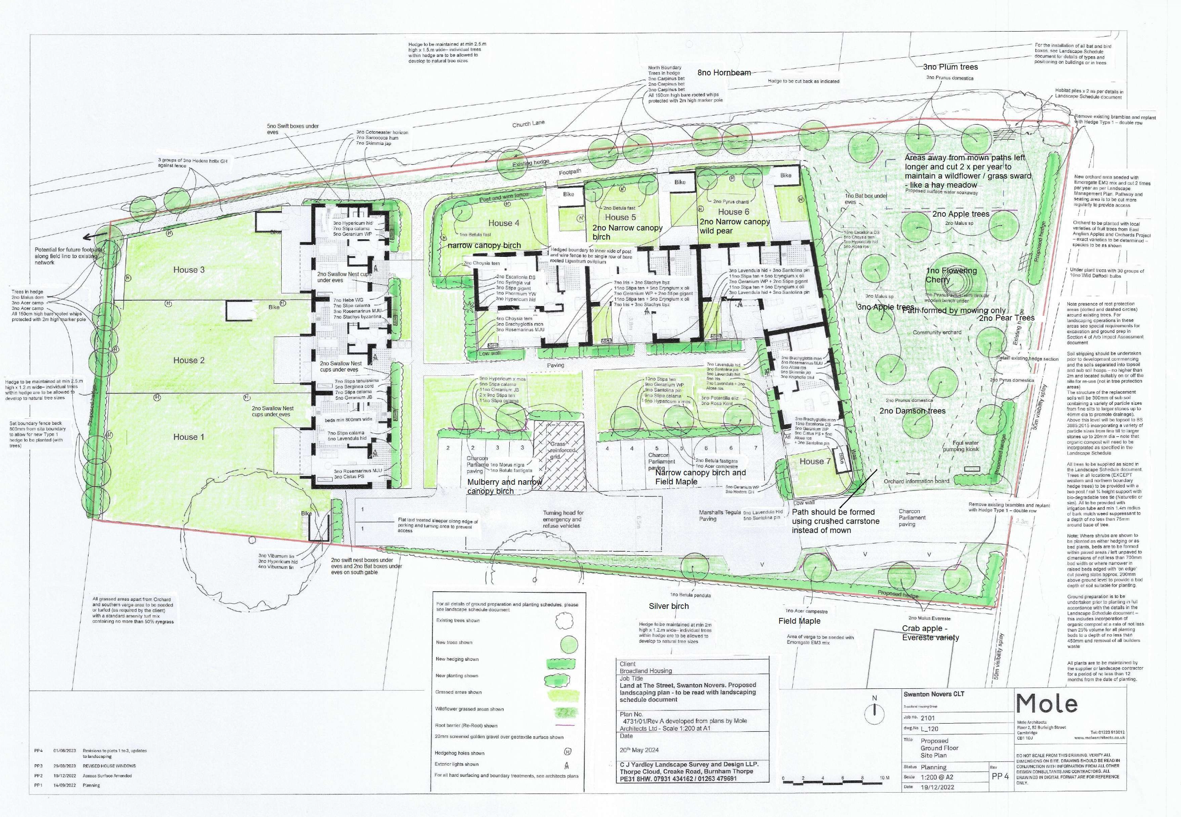

Appendix B – Certificate of Public Liability Insurance

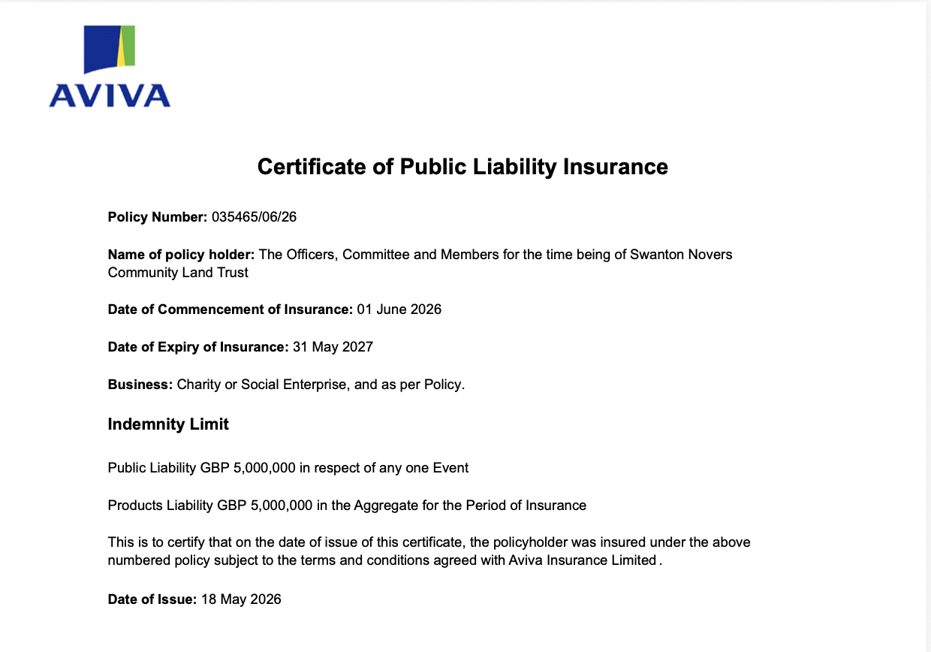

Appendix C – Insurance Certificate Covering Volunteers
